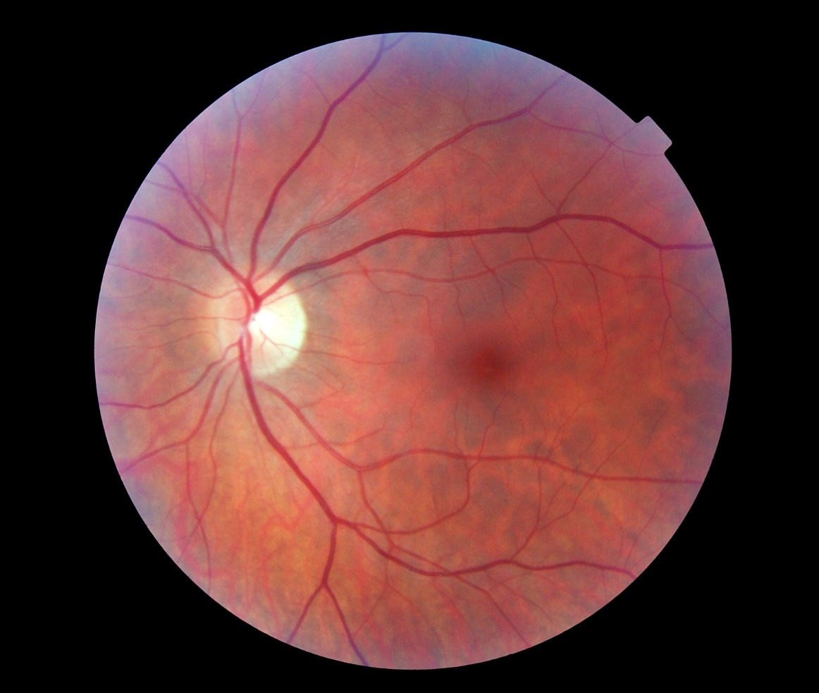

**GP Practice**

**Guide to the Diabetic**

**Eye Screening Programme**

**Contents**

[1. Introduction 3](#_Toc496791955)

[What is Diabetic Retinopathy? 3](#_Toc496791956)

[2. Referrals to Screening 4](#_Toc496791957)

[Who Should be Referred to Screening? 4](#_Toc496791958)

[When to Refer? The Need for Speed 6](#_Toc496791959)

[Data Sharing: Overview 7](#_Toc496791960)

[MIQUEST Data Exports 7](#_Toc496791961)

[HI Hub 8](#_Toc496791962)

[Patients who have NOT Consented to Data Sharing 8](#_Toc496791963)

[Addendum to the Data Sharing Agreement for Learning Disability Codes 9](#_Toc496791964)

[3. The Screening Process 9](#_Toc496791965)

[Changes to Screening Clinics 9](#_Toc496791967)

[The Screening Appointment 10](#_Toc496791968)

[Hosting a Screening Clinic 11](#_Toc496791969)

[After Screening 12](#_Toc496791970)

[Screening Intervals 12](#_Toc496791971)

[4. Grading, Results & Referrals 13](#_Toc496791972)

[What do the Results Mean? 13](#_Toc496791973)

[Referrals to Hospital Eye Services 16](#_Toc496791974)

[Routine Non-Diabetic Referrals 16](#_Toc496791975)

[How to Access your Patients Results 17](#_Toc496791976)

[5. Outreach, DNA’s and Hard to Reach Groups 17](#_Toc496791977)

[Outreach and Education 17](#_Toc496791978)

[DNA’s 17](#_Toc496791979)

[Hard to Reach Groups 18](#_Toc496791980)

[6. Feedback and Contacts 18](#_Toc496791981)

[Feedback 18](#_Toc496791982)

# **Introduction**

Diabetic Retinopathy used to be the commonest cause of blindness in the UK working age population. Thanks to a national Diabetic Eye Screening Programme, this is no longer the case. Everyone who has Diabetes is at risk of developing this sight-threatening condition, but early detection through screening, and early treatment, can prevent sight loss.

The Hampshire and Isle of Wight Diabetic Eye Screening Programme (HIOW DESP) was founded in April 2017, combining parts of three other local services (Southampton and Isle of Wight, Salisbury and North Hampshire, and Portsmouth & South East Hampshire). We now offer a county-wide Diabetic Eye Screening service. Thanks to the co-operation and assistance of GP surgeries in Hampshire and the Isle of Wight, the transition has been very successful.

We hope this guide will be a useful resource for GPs, diabetic nurses, and administrative staff based at GP Practices, as we work with you to provide the best possible service for our patients. You will find an overview of referrals to screening, data exports and data sharing, the screening appointment, what the results mean, and what happens afterwards.

## What is Diabetic Retinopathy?

Diabetic Retinopathy (DR) is caused by damage to the blood vessels in the retina, which detects light at the back of the eye. The retina uses a lot of oxygen, so there is a dense network of fine vessels to supply it. Blood vessel walls get damaged by raised blood glucose levels, until they can no longer supply enough oxygen. As DR progresses, the retina becomes increasingly starved of oxygen, until it responds by growing new blood vessels. It is these new vessels which can ultimately cause blindness, but they can be stopped with laser treatment at an eye hospital.

# T:\008 - Marketing\Pictures & Images\DESP\IMG_0238 2.jpg**Referrals to Screening**

## Who Should be Referred to Screening?

All people with any type of diabetes are entitled to receive retinal screening if they are eligible. Patients are eligible for screening if they are:

* Over 12 years old
* Able to perceive light with at least one eye

Patients may reasonably be excluded from the programme if they are unable to benefit from screening, for example if they are:

* Already blind with no perception of light in either eye
* Housebound or bed-bound
* Terminally ill

Exclusions can be permanent, or temporary if a patient is unable to attend due to illness or injury. Temporary exclusions last a maximum of 6 months. Patients may opt out for 1 year by direct request to our bookings team, although we do our best to talk them out of it.

Gestational diabetes does not require screening because the condition is temporary. Sometimes GP’s may hesitate to refer someone if their diabetes is ‘borderline’. We would encourage you to refer in such cases, as even mildly raised blood sugars can cause DR, especially when other cardiovascular risk factors are present. If you are in any doubt about the eligibility of a patient, please contact us for advice.

**People already under the care of Hospital Eye Services** should still be referred into screening. We at HIOW DESP have Failsafe Officers embedded in hospital Ophthalmology departments who will receive written reports from hospital clinics. The reports tell us if the patient is under the care of a Medical Retina Specialist, and whether their Retinopathy grade is being assessed. If we cannot verify that they are receiving an appropriate substitute for screening, we will offer them a screening appointment.

**People with a physical disability** should be referred if they are sufficiently mobile to access the screening equipment. When we are carrying out screening, we do not have access to specialist mobility equipment such as hoists, nor are we able to lift patients ourselves. However, we can accommodate wheelchairs including motorised versions. If a patient cannot sit forwards, we might still be able to screen them with a slit lamp examination instead of using digital photography, but we will try to obtain photographs first. If a person is housebound, they might still be able to attend with appropriate transport arrangements and the help of a carer.

**If a person needs Hospital transport** to attend their screening appointment, it is the responsibility of their GP Practice to arrange it.

**People with sensory impairments** will have their needs accommodated wherever possible. Our bookings team can arrange for a British Sign Language interpreter to attend at appointments. We can use the telephone service Language Line, to provide live translation during appointments. Guide dogs are welcome at screening appointments, and there is an audio version of the Public Health England diabetic eye screening leaflet available on our website: [www.desphiow.co.uk](http://www.desphiow.co.uk).

We are rolling out a telephone message appointment reminder service, which will benefit people with sight impairment.

**People with a learning disability or dementia** should be referred to us if they have capacity to consent to screening, and are able to follow simple instructions. If a patient has a learning disability, it is important for you to accurately code patient profiles so that we are aware of this. We can then make reasonable adjustments to our service, which can be tailored to the individual needs of our patients.

We aim to make our service as accessible as possible to people with complex needs. These people have the most to lose in terms of independence and quality of life if they suffer vision loss because of DR. If you are in any doubt about the eligibility of your patients, please refer as standard. You are always welcome to discuss any concerns you may have with us at HIOW DESP.

If we are unable to screen someone, we may request that you exclude them. This will only happen in exceptional circumstances, when there is no possibility of obtaining adequate images. If you are not sure whether to exclude someone, please contact us for advice. You will find contact details at the back of this guide.

## When to Refer? *The Need for Speed*

As soon as a person is diagnosed with diabetes they are known to be at risk of developing Diabetic Retinopathy. We at HIOW DESP are required to offer our new patients a screening appointment **within 3 months of referral**. This is to minimise the risk of sight loss while waiting for the first appointment. However, if it takes a long time for somebody’s GP to refer them to us after diagnosis, it might still be too late.

## Data Sharing: Overview

Practices are requested to sign a Data Sharing Agreement (DSA) allowing us to run monthly MIQUEST exports, this identifies newly diagnosed patients with diabetes that require a referral to the Diabetic Eye Screening Programme and negates the need to perform manual validations.

Health Intelligence have developed a portal called ‘HI Hub’ to serve as the interface for GP Practices and the Programme. You will not need to download any extra software, as it runs on your browser.

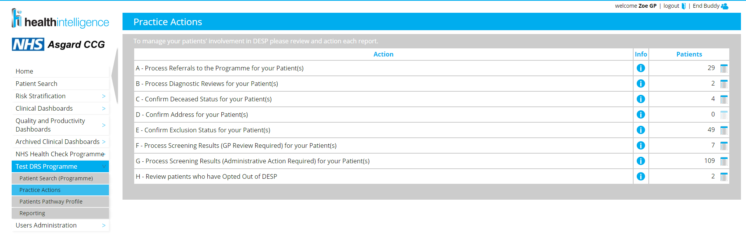

## MIQUEST Data Exports

A MIQUEST data export will need to be run before you can start using HI Hub. This ensures that our records of your patients, e.g. contact details, clinical codes etc., are up to date and aligned with yours. When a patient is first diagnosed with diabetes, the clinical code will be picked up during this process. You will only be able to refer someone using HI Hub once their code has been exported, so we will ask you to carry this out monthly.

MIQUEST exports are done in partnership with our Support Services team. Support Services will arrange a date and time to conduct the export, and will go through it on the phone with the designated person. Once this is done, you are ready to begin using HI Hub. It takes about 24 hours for a data export upload to refresh the reports and apply any changes onto HI Hub. You will then need to log in to HI Hub and confirm any updates, following the training which will be delivered by the Support Services team.

## HI Hub

HI Hub is used to refer patients into screening, download results from screening appointments, and update deceased and exclusion status for your patients. The referral process is very easy: once you have logged in to HI Hub, you will see a section called ‘Practice Actions’ in the menu. This section of HI Hub contains all the actions your Practice needs to undertake, including the number of outstanding referrals to screening. From here, you can access a list of all outstanding candidates and refer them with a couple of clicks, then an invitation to screening will be generated.

HI Hub users will receive any training they need from Support Services ([supportdesk@health-intelligence.com](mailto:supportdesk@health-intelligence.com)); following the training, user guides are issued for reference. You will find contact details in section 6 of this guide.

You can add as many users as you need. You will need to have at least one person signed up as a user, but it is advisable to have a second person trained in case of absence. Either clinical or administration staff can use HI Hub. It can be useful to have a Diabetic Nurse signed up, as they can access the images from screening, which may help in their patient consultations.

## Patients who have NOT Consented to Data Sharing

Sometimes a patient might refuse to be referred to us due to concerns about data sharing. In this specific case, there is a clinical code you can use which prevents them from appearing on MIQUEST exports or on HI Hub. When this happens, the patient is then responsible for their own care. As GPs, you should advise these patients of the risks attached to a refusal to be referred, but the choice lies with the patient.

Once a year, we will ask you to run an audit of patients who have dissented to be referred to us; contact those patients to ensure that they have not changed their minds and are aware of the risks. We can supply a MIQUEST script for this purpose.

## Addendum to the Data Sharing Agreement for Learning Disability Codes

HIOW DESP has added an addendum to the DSA, asking you to share clinical codes that identify people with a Learning Disability. This is to help us provide adjustments to our service for this cohort of patients, and assess attendance rates separately, so that we can measure the effectiveness of the changes we make.

# **The Screening Process**

## T:\008 - Marketing\Pictures & Images\DESP\IMG_0225.JPG

## Changes to Screening Clinics

With the creation of the new Hampshire-wide screening programme there have been changes to the way we offer screening in some areas. If your Practice is in Portsmouth or South East Hampshire, the screening process has not changed and your transition to the new programme should be seamless.

If your Practice is in Southampton, the Isle of Wight or West Hampshire, the biggest change you and your patients will notice is that we no longer screen from mobile units. We now offer static clinics, which run continuously through the year. These are supplemented with temporary clinics which are set up for a fixed period, in a rotating manner, so that we can expand from our core locations. However, despite our best efforts, we will not be able to offer as many locations as the previous Southampton based programme. As the programme matures, we will aim to improve accessibility by offering a wider choice of appointment times, including evening and weekend appointments.

If your Practice is in North Hampshire, your patients will notice that their screening appointments no longer include a discussion with the Screener about their primary grade. The primary grade is the first part of a multi-stage image assessment process. This means that a primary grade can be overridden by a subsequent Grader, and therefore it’s accuracy is not guaranteed. For this reason, the National guidelines for DESPs advise against giving a primary grade at screening. Hampshire and Isle of Wight DESP will follow the National guidelines, and send patients their results in the post once the grading process is complete.

Our clinics operate in GP surgeries and community centres throughout Hampshire and the Isle of Wight. Each is run by a Screener, who will capture retinal images and return them to the office for grading. We have a core set of clinics which run throughout the year, supplemented by temporary clinics which will be available for several days or weeks at a time. You can find a list of locations on our website at [www.desphiow.co.uk](http://www.desphiow.co.uk).

## The Screening Appointment

When a patient arrives for a screening appointment, they are called from the waiting area and greeted by the Screener. We will ask patients to sign a consent form to confirm that they understand the screening process, and that we may store their data on our computer system and share this information with other relevant health care providers. This also gives them their first opportunity to ask questions or voice any concerns they have.

We will then measure their visual acuity at 3 metres. Patients will need to bring their distance glasses to the appointment to obtain an accurate measurement. The patient will have dilating drops (1% Tropicamide) administered to their eyes. There will be a short wait of about 15 minutes while the drops take effect.

Once their pupils have dilated, the patient is brought back for their photographs. Two 45 degree retinal images will be taken of each eye, one which is macula-centred, and one which is disc-centred. If there is any problem obtaining clear images of the retina, additional images will be taken. The images are given an initial triage status, before being securely uploaded on our screening software.

Patients will be given a Friends and Family card to leave feedback after their appointment.

## Hosting a Screening Clinic

Our clinics usually run from 9 to 5, with appointments from 9.10 to 4.20. Each appointment is 10 minutes long, though patients will be sent back to the waiting room for 15 minutes while their pupils dilate. The Screener on duty will print a clinic list for Reception on blue paper. This is shredded at the end of each clinic. Our clinics do not use your surgery’s check in system, so patients do not need to sign in, unless you require this for your own fire safety measures.

Screening rooms need space for a vision chart 3 metres from the patient, and a motorised table with the fundus camera on it. Hand washing facilities are appreciated. We like to be able to darken the room during photography. If the camera needs to be moved between clinics, our IT team will collect it. When the camera is not used, secure storage will be needed.

## After Screening

Patients often find their vision is blurry and everything appears a bit brighter, after administration of the drops. This can last for 3-6 hours. They are advised to bring sunglasses for their own comfort afterwards.

Patients are advised that they should **NOT DRIVE** after their appointment. They are informed about this in their invitation letter and during the appointment.

## Screening Intervals

Most eligible patients are screened once in every 12 month period. Some patients may be screened between every three and six months on an individual basis under Digital Surveillance. This happens if there is a level of retinopathy which falls short of the criteria for referral to eye hospital, but which is considered too risky to leave for a year. Sometimes eye hospitals will discharge borderline patients directly into Digital Surveillance instead of annual screening. This ensures patient safety while relieving pressure on the hospital.

**Patients who are pregnant** are screened once in every trimester, and once again 3 months post-partum, before being returned to annual screening.

**Patients who have been referred to a Hospital Eye Service** for Diabetic Retinopathy will be suspended from screening until discharged, but will stay registered with the screening programme. At the point of discharge, a copy of the discharge letter will come to the screening service, and they will be re-invited to screening at the appropriate time.

# **Grading, Results & Referrals**

Images taken during screening are assessed, and the Retinopathy grade assigned, in one of our grading offices. Qualified Graders must have either the City and Guilds Diploma in Diabetic Retinopathy Screening or the new Diploma for Health Screeners (Diabetic Eye), and must grade a sufficient quantity of image sets per year to maintain their skills. Medical Retina Specialists are also permitted to grade. Grading is subject to internal and external quality assurance, to ensure our results are accurate.

Grading takes place in a dimmed environment, using large high-resolution screens. Each eye is given a separate R-grade for Retinopathy and M-grade for Maculopathy. We will also assess the retina for any non-diabetic pathology that could cause visual loss, although we cannot replace regular check-ups with an Optometrist. Patients receive their results in the post shortly after the screening appointment.

## What do the Results Mean?

**R0 – No Retinopathy**

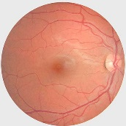

A healthy retina showing the optic disc, where vessels and nerves enter the retina; the fovea, which generates central vision; the macula, which is the area between the vessels that surround the fovea; and the peripheral retina.

**R1 - Background Retinopathy**

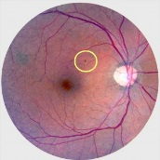

This is the earliest stage of Diabetic Retinopathy and is not sight threatening. The first visible signs of blood vessel damage appear at this stage, including small haemorrhages, and microaneurisms.

**R2** **- Pre-Proliferative Retinopathy**

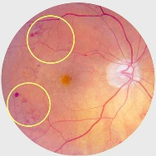This is the manifestation of increasing oxygen deficiency. Visible signs are large, deep or numerous haemorrhages; abnormal patterns of fine blood vessel growth; and visibly bulging, sausage-like vessel walls. This stage of Retinopathy is not directly sight threatening, but carries a high risk of progression to R3, and needs careful monitoring. Good diabetic control for people with R2 Retinopathy is vital, to reduce the risk of progression.

**R3a - Proliferative Retinopathy**

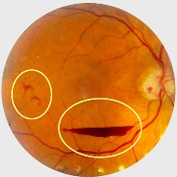This is the sight threatening, advanced form of Diabetic Retinopathy. By this stage, the retina is trying to compensate for a lack of oxygen by growing new blood vessels. These new vessels are abnormal and fragile. They can rupture, causing serious bleeds, and tend to become surrounded by scar tissue, which tightens and causes retinal tears and tractional retinal detachments. At this stage, laser treatment at an eye hospital is urgently needed to prevent blindness.

**R3s – Stable Proliferative Retinopathy**

This is previously treated Proliferative DR that is stable, i.e. there has been no change compared to a previous set of reference images.

**M1 – Maculopathy**

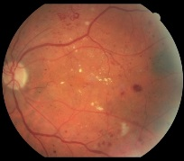This is visible signs of oedema in the macular region. When the blood vessels are damaged, fluid leaks out into the retina, where it interferes with normal functioning. The oedema leaves behind a yellow sediment, called exudate. Exudate close to the fovea is likely to impair visual acuity, and requires further assessment by a hospital eye service. Maculopathy can be treated with injections.

**U – Unassessable**

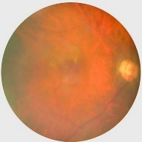This grade is given if we are unable to obtain clear, complete and adequate images of the retina. This is usually due to cataract, corneal scarring, or some other opacity that obscures the retina. A U grade generates a referral to the Slit Lamp Biomicroscopy clinic. This is a separate screening test carried out by an Ophthalmologist from our subcontracted Optometry team, assisted by one of our Screeners.

## Referrals to Hospital Eye Services

Patients who are referred to hospital eye services will be given an appointment on a timescale set by the National Diabetic Eye Screening Programme.

**Same day referrals** are made if we see evidence of immediately sight threatening disease or injury, either at the screening appointment or during grading. It does not matter if it is caused by diabetes – if we suspect that there is a serious and immediate risk to a patient’s sight, we will arrange an appointment at the nearest Eye Casualty department within 24 hours.

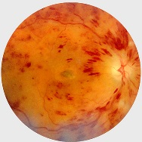

**Urgent referrals** will result in an appointment **within 6 weeks**. Urgent referrals will be made if a grade of R3a is given. If we identify a non-diabetic condition that carries a high risk of sight loss, e.g. wet AMD, vein occlusion, or choroidal melanoma, we will make an urgent referral ourselves.

**Routine Diabetic Referrals** will result in an appointment within **13 weeks**. Grades of R2 or M1 will generate a routine referral.

**Referrals to Slit Lamp Biomicroscopy** will be made if a U grade is given, and patients will be offered an appointment within **12 weeks**.

## Routine Non-Diabetic Referrals

If we identify a non-diabetic condition that warrants a routine referral, we will advise you via your patient’s results. **It is then your responsibility to make the referral.** Please ensure you download results from HI Hub regularly.

## How to Access your Patients Results

If you have signed up to the DSA, you will be able to download your patients’ results directly from HI Hub. It is important that your Practice does this regularly so that you can carry out any routine referrals in a timely manner. HI Hub users will be able to see how many results letters are waiting to be downloaded under the ‘Practice Actions’ menu. There is a separate list for results which require the GP to act, i.e. make a routine non-diabetic referral. Results can be downloaded as a zip file, which is secure as it is encrypted.

# **Outreach, DNA’s and Hard to Reach Groups**

## Outreach and Education

We are committed to outreach and education for patients, carers and other healthcare professionals. We regularly attend Diabetes conferences and education days. If you would like us to participate in any educational events or forums, please contact us. We are also happy for clinicians to spend time observing us while we carry out screening clinics and grade images. If you would be interested in finding out more about our service, please get in touch.

## DNA’s

When a patient does not attend during a given 12-month period, we say they ‘Did Not Attend’ (DNA) their screening appointment. This is distinct from a single missed appointment. Our data analytics team run annual audits of our DNA’s to try to work out the underlying factors causing people to disengage from screening. The results of this work will inform an evidence based strategy to optimise screening uptake.

## Hard to Reach Groups

We are aware that some cohorts of patients tend to be less engaged with health care providers and can be difficult to reach. This can include vulnerable adults such as homeless people, people serving a prison sentence, people who are housebound, and people with a learning disability. We are committed to engaging with hard to reach groups as much as possible, as it is people who either cannot or choose not to access healthcare who are at highest risk of having undiagnosed, sight threatening Diabetic Retinopathy.

# **Feedback and Contacts**

## Feedback

We welcome feedback from GPs about their experience with the Hampshire and Isle of Wight Diabetic Eye Screening Service. If you have any concerns about your patients’ experience of our service, please do not hesitate to contact us.

In addition, an annual survey is conducted on our behalf by a company called Breaking Blue. The content is of special interest to us, and we will be very grateful if you would complete it.

Thank you for reading this guide. If you have any queries, please contact us using these details:

**Address:**  Suite E, Anchor House, School Lane, Chandler’s Ford, Eastleigh, SO53 4DY

**Bookings Telephone:** 01983 898 700

**Office (Programme Management) Telephone:** 01983 898 334

**Failsafe Telephone:** 01983 898 335

**Fax:** 01983 898 336

**Email:** [enquiries@desphiow.nhs.net](mailto:enquiries@desphiow.nhs.net)

**Secure email for queries containing patient data:** [enquiries.desphiow@nhs.net](mailto:enquiries.desphiow@nhs.net)

**Support Services Telephone:** 01270 527 373

**Support Services:** [supportdesk@health-intelligence.com](mailto:supportdesk@health-intelligence.com)

**Website:** [www.desphiow.co.uk](http://www.desphiow.co.uk)



*The Hampshire & Isle of Wight Diabetic Eye Screening Programme is provided by Health Intelligence Ltd, commissioned by NHS England South (Wessex) as part of the National Diabetic Eye Screening Programme*