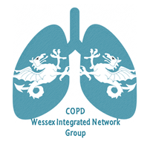
26th September 2018
Balmer Lawn Hotel and Spa, Brockenhurst, SO42 7ZB
COPD Wessex Integrated Network Group
Date for your Diary!
Theme: Preparing for Winter
Talks will be dedicated to recognising when to treat chest infections/exacerbations (and what with), and the truth about vaccinations!
There will be round-table discussions on use and overuse of rescue packs in practice and more…..
See you there!
The afternoon will start at 5.30 with refreshments and buffet with networking opportunities.
Talks will begin at 6pm.
The meeting is sponsored by Pfizer Ltd, TEVA UK, Glaxo Smith Kline, Astra Zeneca, Boehringer Ingelheim, Thermo Fisher Scientific and Nutricia.
They have a promotional stand at the event and have no influence on the lectures or agenda of the meeting.

Please email helen.kruk@uhs.nhs.uk to book your place!

