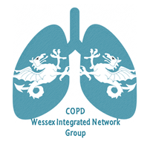
27th March 2019
Venue TBC
COPD Wessex Integrated Network Group
(WING)
5.30pm to 8.45pm
Food will be served from 5.30 and available for latecomers, if you let us know you will be late.
Theme: Home oxygen therapy and Non Invasive Ventilation services.
Prof. Nick Hart will talk on the HOT-HMV study results and implications for clinical practice.
The Portsmouth Respiratory team will talk on their local NIV service.
There will be round-table discussions to follow the talks.
See you there!
The afternoon will start at 5.30 with refreshments and buffet with networking opportunities.
Talks will begin at 6.30pm.
The meeting is sponsored by various Pharmaceutical companies, and the list will be confirmed nearer the meeting date.
They have a promotional stand at the event and have no influence on the lectures or agenda of the meeting.

Please email helen.kruk@uhs.nhs.uk to book your place!

