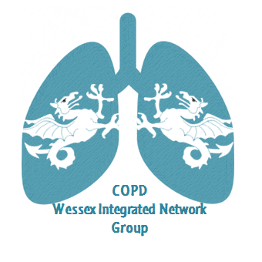
Wessex Integrated Network Meeting
25th September, 2019
Bartley Lodge Hotel, Lyndhurst Road, Cadnam, SO41 2NR
“Effective smoking Cessation: this is all of our business”
17.00 – 17.45 Steering group meeting – all and anyone welcome!
17.30 Refreshments, food and networking
18.30 The scale of the problem, background, levers and obstructions.
Dr Richard Russell, Respiratory Consultant, LNFH
19.00 The nature of addiction. Scientific underpinning, what we need to know and what can help us when helping people quit
Anya Farnborough, University of Southampton
19.30 How to be effective at smoking cessation. When, where and how to help people quit
Lisa Fendall, National Trainer in Smoking Cessation
20.00 What is possible? How to embed smoking cessation into your service.
Heidi Croucher, Smoking in Pregnancy Specialist Midwife, Poole Hospital
20.30 Q and A with all speakers
All

To book your place, please email H.Kruk@soton.ac.uk

