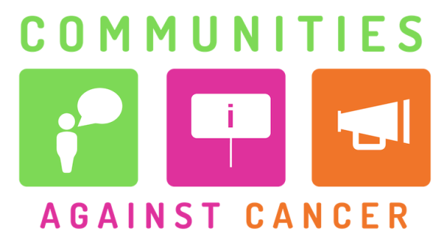
Communities Against Cancer 2019-20
SMALL GRANTS application form (up to £500)
Please ensure you read the guidance notes before completing this form

ORGANISATION AND PROJECT GENERAL DETAILS
(THIS FIRST BLOCK IS JUST FOR ORGANISED GROUPS TO FILL IN)
Name of organisation making this application
Address of organisation’s main office (if it has one) |  |  | Postcode
Type of organisation
(e.g. registered charity, CIC)
Registration number(s)
(e.g. charity, company)
Full names of 3 people involved in running the organisation (1 of these can be the person completing this form)
INDIVIDUALS AND INFORMAL GROUPS CAN ALSO APPLY TO THIS GRANT FUND
PLEASE IGNORE THE ABOVE SECTIONS IF YOU ARE AN INDIVIDUAL, NOT AN ORGANISED GROUP
Name of main contact person for this application
Correspondence address  (if different from above) |  |  | Postcode
Daytime telephone number
Email address
Planned project start date |  | Planned project end date
Where will you run your project?
What sort of people will benefit from your project?
Total amount requested (maximum £500)
Where did you hear about the Communities Against Cancer programme?

ABOUT YOUR ORGANISATION AND PROJECT
Brief description of your organisation or group (individuals can ignore this question)
(100 words maximum) Please give an overview of what your organisation does, focusing on what kind of work you do with our target communities.

Why is this project needed?
(200 words maximum) Please explain who will benefit from this proposal, and why you think they are less likely to know how to look after their health or are less able to do so.

What do you want to do?
(200 words maximum) Please tell us about what you want to do with this grant, including an estimate of how many people you will reach.

How will your project help people?
(200 words maximum) How will your project improve the cancer-related health of the people you intend to help?

COSTS BREAKDOWN
You can apply for up to £500. Please complete the table below, only including the costs for this project that is the focus of your grant application.

Receiving the grant: If you are an organised group then we may be able to pay the grant to you directly, or you may need to find a larger organisation to hold the grant money for you. We will confirm this later if your application is successful. If you are an individual or an informal group then we will hold the money for you and pay invoices or reimburse receipts.

Please give a clear breakdown of all costs, e.g.
- Venue hire, advertising, refreshments, and other event-related costs
- Volunteer costs
- Designing and printing leaflets, posters etc.
- Staff costs, for example if you are buying in some staff time from a larger organisation
- Other actual direct costs you expect to incur in delivering the project

Type of cost | Cost for this item | Breakdown of the cost
 | £
 | £
 | £
 | £
 | £
 | £
TOTAL COSTS | £
TOTAL SUM APPLIED FOR | £

If your project costs more than you are asking us for, please answer the two points below
How you will make up
the project cost shortfall
When you expect to have all the
funds needed for this project

CHECKLIST BEFORE YOU RETURN YOUR APPLICATION
Please use this section as a checklist and tick the boxes to confirm:
If you are applying as an organisation, have you included your Rules or Constitution? |  | Have you answered every question and typed your full name in the section below?
Have you checked the figures in your budget all add up? |  | Have you checked your word count in each section?

CERTIFICATION
By submitting this application I confirm that the information on this form constitutes a true overview of the project and (for applications from organised groups) gives a true picture of our organisation.

Full name of person submitting application

RETURNING YOUR APPLICATION
Please return your completed application to:
info@actionhampshire.org
Or: Communities Against Cancer
Action Hampshire
Westgate Chambers
Staple Gardens
Winchester, SO23 8SR

You can also apply by calling us or emailing a video to us. Please contact Kevin Sawers on 01962 857358 or by email and we will help you do this.

For postal applications please use the correct payment.
We also recommend that you use recorded delivery.
We will acknowledge applications we receive by email, so please contact us if you do not get an acknowledgement.

The application deadlines are on Friday 30th August and then the last working day of each month, up to Friday 28th February 2020.

FOR OFFICE USE ONLY
Date application received |  |  |  | Date application acknowledged
Application eligible? | YES / NO | Signature |  |  | Date
If not eligible, please explain here

