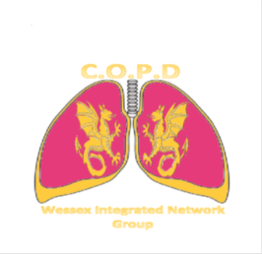

Wessex Integrated Network Meeting
14th December 2017, 5.30 – 8.30pm
Chilworth Manor, SO16 7PT
************
17.30 Refreshments and networking
18.00 Identifying and preventing exacerbations
Professor Tom Wilkinson, Professor of Respiratory Medicine and Honorary NHS Consultant Physician
18.20 Research and the practical implications of treatment of exacerbations.
Professor Mona Bafadhel, Associate Professor & NIHR Postdoctoral Fellow Respiratory Medicine, University of Oxford
19.00 Food and networking
19.20 SCAS – response to call out for exacerbations
Pete Warren, Clinical Governance Lead 999 South
19.35 My experience of an exacerbation
Molly Bennett, PPI Portsmouth
19.45 Round table discussions
20.15 Feedback
20.30 Close
To book your place, please email helen.kruk@uhs.nhs.uk

