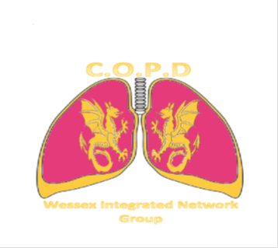
13th MARCH 2018
Balmer Lawn Hotel, Lyndhurst Rd., Brochenhurst, SO42 7ZB
AGENDA
COPD Wessex Integrated Network Group
Date for your Diary!
The March meeting is now booked at the Balmer Lawn Hotel, Brockenhurst.
The evening theme is Self-Management for COPD.
A full agenda will be sent out very soon.
As usual, the meeting will begin at 5.30 with refreshments, and the full programme will commence at 6.30pm.

See you there!
The meeting is sponsored by Pfizer Ltd, TEVA UK, Glaxo Smith Kline, Astra Zeneca, Boehringer Ingelheim and Novartis.
They have a promotional stand at the event and have no influence on the lectures or agenda of the meeting.

Please email helen.kruk@uhs.nhs.uk to book your place!

