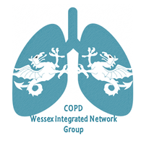
Wessex Integrated Network Meeting
13th March 2018
Balmer Lawn Hotel and Spa,
Lyndhurst Road, Brockenhurst, SO42 7ZB
xxxxxxxxxxxxxxx

17.30 Food networking and discussion
18.30 Introduction
Dr David Paynton, Clinical Lead, Southampton Better Care.
18.40 “Solent NHS COPD personalised care planning and patient activation”
Carl Adams, Trainee Consultant Practitioner in Neurological Rehabilitation.
19.00 “Online communities and their use in long-term condition self-management support”
Chris Allen, Lecturer, Lead on Adult Nursing Programme (year 3), Portsmouth
19.20 Introduction to the round table discussions
Dr Zoe Pond, Respiratory Physician, University Hospitals Southampton, Clinical Lead Southampton City Integrated COPD Team
19.30 Round table discussions – all
20.30 Feedback discussion points, each table
20.45 Closing remarks
To book your place, please email helen.kruk@uhs.nhs.uk

