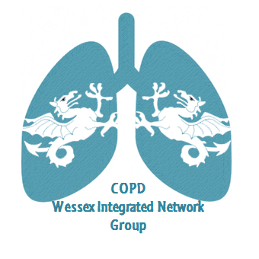
Wessex Integrated Network Meeting
21st June 2018, 5.30 – 8.45pm, Chilworth Manor, SO16 7PT
17.30 Refreshments, food and networking
18.30 Introduction to the evening by Chair
Sarah Kearney, Respiratory Nurse Specialist, IOW
18.40 Factors that affect lung deposition
Professor Joy Conway, Professor of Inhalation Sciences, University of Southampton
19.10 Demo 1: the In-check device
Mrs Carla Astles, Practice Nurse
19.20 Demo 2: the RightBreathe website
Mrs Emma Ray, Research Fellow and Respiratory Nurse
19.30 Round table discussions (with coffee)
a) How can we help make the consultation more effective/efficient when choosing the right device for the right patient?
b) What are the most efficient ways to facilitate the right inhaler for the right patient using the right people?
c) Are there other people best placed to help the patient correctly use their chosen inhaler?
d) Is there a default ‘set’ of devices that could be used in a consultation to aid both clinician and patient?
20.15 Feedback
20.45 Close
To book your place, please email helen.kruk@uhs.nhs.uk

