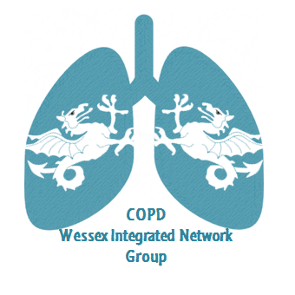
Wessex Integrated Network Meeting
25th June 2019
Chilworth Manor Hotel, Southampton, SO16 7PT
17.00 – 17.45 Steering group meeting – all and anyone welcome!
17.30 Refreshments, food and networking
18.30 Introduction to the evening by the Chair
18.40 Use of HFNO at home, discussion and case studies
Matt Quint, Specialist physiotherapist, QAH, Portsmouth.
19.10 Challenges with Home Oxygen use and removal
Sue Channon, Home Oxygen Contract Manager and Regional HOS Lead.
19.40 Oxygen guideline development and challenges.
Dr Jay Suntharalingham, Consultant Respiratory Physician, BTS Oxygen Guidelines Committee
20.10 Q and A with all speakers, with open discussion around oxygen use and challenges
All
20.40 Close
To book your place, please email H.Kruk@soton.ac.uk

