NHSE&I Toolkit
It includes key messages, newsletter/bulletin items, links to a radio recording, video a webinar and recording and slide pack and suggested social media posts for pharmacies to customise and to use in communications and engagement work.
Key Messages:
- High blood pressure is a major risk factor for cardiovascular disease (CVD) and significantly increases the risk of having a heart attack or stroke, but early detection and treatment can help people live longer, healthier lives.
- Cardiovascular disease (CVD) is the second most common cause of premature death in England, after cancer, affecting seven million people. One in four premature deaths are caused by CVD and it is and a leading cause of disability.
- NHS England is supporting World Hypertension Day and the International Society for Hypertension’s May Measurement Month campaign, which aims to increase high blood pressure awareness in all populations around the world.
- Since October 2021, community pharmacies across England have been offering a NHS blood pressure check service to people over 40, as an easy and convenient way for people to get their blood pressure checked. The service can be offered opportunistically or at the person’s request.
Bulletin Items:
May Measurement Month
This month we are supporting the International Society for Hypertension’s May Measurement Month campaign, which raises awareness of the risks of high blood pressure and encourages people to get their blood pressure checked regularly . We have published various resources and developed communications to encourage people to ‘know their numbers’ and get their blood pressure checked to prevent heart attacks and stroke.
You can watch our video on the NHS blood pressure check service in community pharmacy, , and watch our webinar recording [insert link]. Also listen out for our radio broadcast across regional channels urging those over 40 who have not had their blood pressure checked or been previously identified as having hypertension or a related condition; to access the service.
World Hypertension Day 17th May
NHS England is supporting World Hypertension League’s World Hypertension Day which aims to increase high blood pressure awareness in all populations around the world and provide information on prevention, detection and treatment.
High blood pressure is a major risk factor for Cardiovascular disease (CVD) and significantly increases the risk of having a heart attack or stroke, but early detection and treatment can help people live longer, healthier lives.
Since October 2021, community pharmacies across England have been able to offer an NHS blood pressure check service to people over 40 as an easy and convenient way for people to get their blood pressure checked. If they are found to have a confirmed high blood pressure reading, the pharmacist can follow up with continuous ambulatory monitoring over a 24-hour period and urgently refer them for further treatment. All blood pressure readings are sent to the GP from the community pharmacy, so records can be updated, and appropriate action taken. GPs can also refer patients to go to their community pharmacy to get their blood pressure checked.
Watch our patient facing video about the service: Blood pressure - visit - YouTube

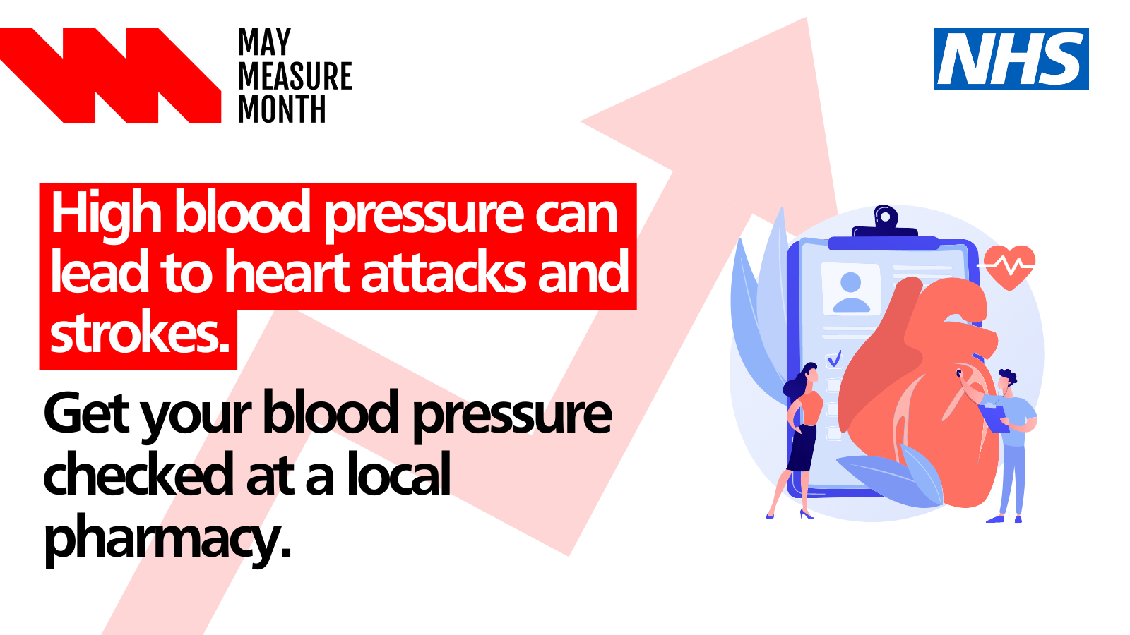

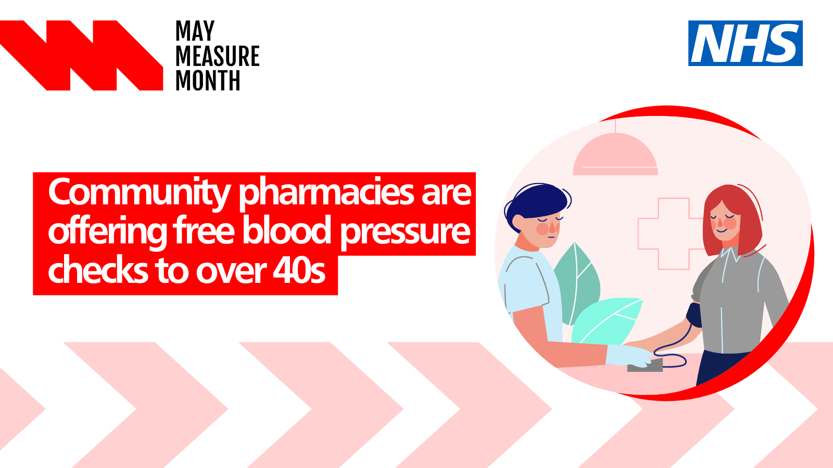
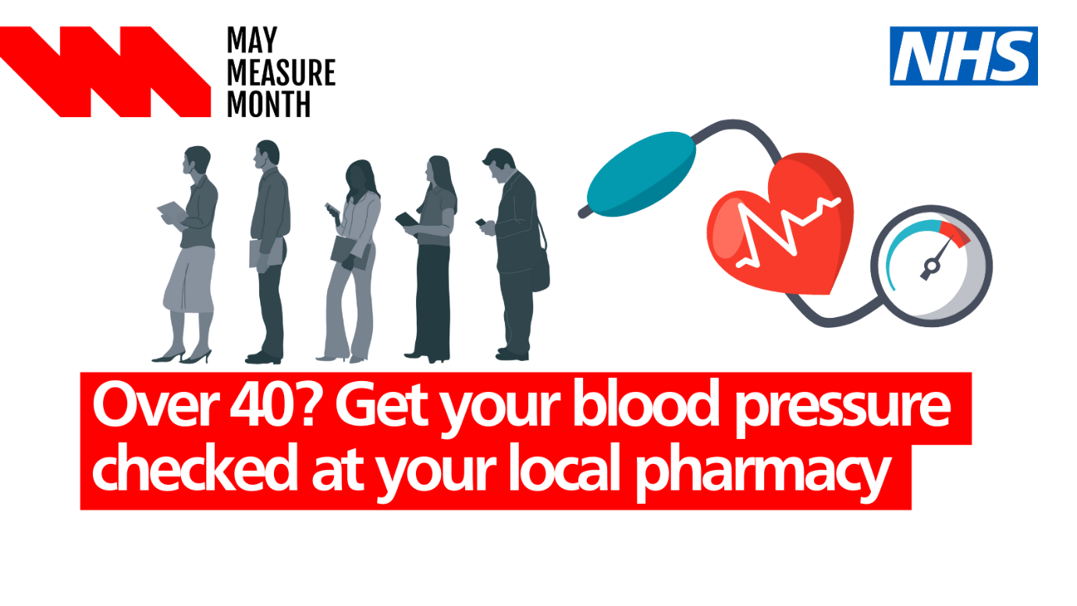
Radio features: To be broadcast on regional stations across England with a particular emphasis in the South West, East of England and South East.
Listen Here
Community Pharmacist Jignesh Patel, talks about the steps in place to spot and prevent the potential development of cardiovascular disease and urges those over 40+ who haven’t been previously identified as having hypertension, or a related condition to get their blood pressure checked at their local community pharmacy.
Read our blog: on 17 May for World Hypertension Awareness Day. It will be published here https://www.england.nhs.uk/blogs/
In this blog, Shahed Ahmad, our National Clinical Director for Cardiovascular Disease (CVD) Prevention, considers how the NHS Community Pharmacy Blood Pressure Check Service is saving lives by making it easy for people to ‘know their numbers’.
Watch our webinar recording and view our slide pack on Future NHS.

