Unpaid Carers Survey
Have your say in what is working well

NHS Hampshire and Isle of Wight are committed to working in partnership with people and local communities and delivering the best possible health and wellbeing outcomes for our population. To help them to achieve this, they want to hear your views, so they are providing you and patients with this quick opportunity to tell:

- What is working well in Health and Social Care?
- What could be better in Health and Social Care?

Who is the survey for?
The survey is for anyone (16 or over) living in Hampshire and Isle of Wight - who is an unpaid carer. That is, you provide unpaid care and support to a family member, friend or neighbour who is disabled, has an illness or long-term condition, (including addiction) or who needs extra help as they grow older.

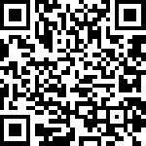

The survey will close at midnight on Sunday 15th March.

